Hi,

Please, I have a website where students’ results are posted, I use DREAMWEAVER, PHP and MYSQL server for this. Student login using their student_id numbers as USERNAME and 12345 as their PASSWORD.

Then they CLICK HERE TO CHECK REPORT on their profile page to check their respective results on the result.php file

What I want is a bar chart that dynamically changes to display the results of each student when they go to result.php. The displayed bar chart will correspond with the student result that is pulled from the table class_room and the chart will be displayed in the table below the results on the result.php file.

I have attached the three files used (login.php, profile.php and result.php) and the code to create the tables needed and insert statements.

Please, I hope you can help me because I am stuck no matter what I try and you can return the files to tosinsog@gmail.com

I tried these two graph libraries: PHPlot or phpgraphlib_v2.31

Sample Graph

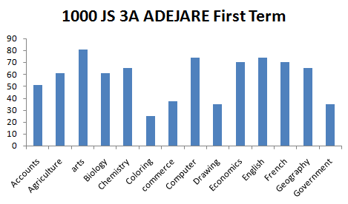

Thank you very much

Tosin Sogunro